Seminar on the jurisprudential services of Hazrat Imam Ja'far al-Sadiq
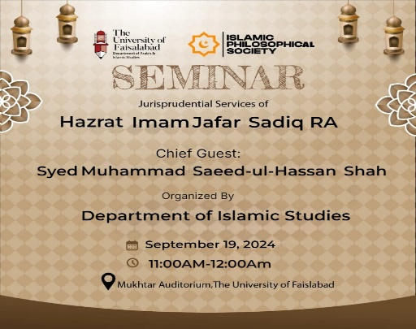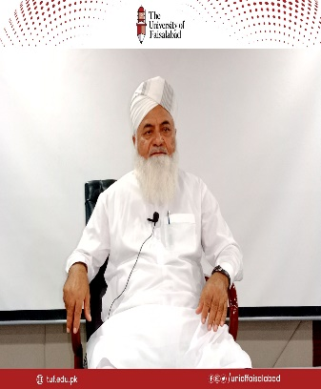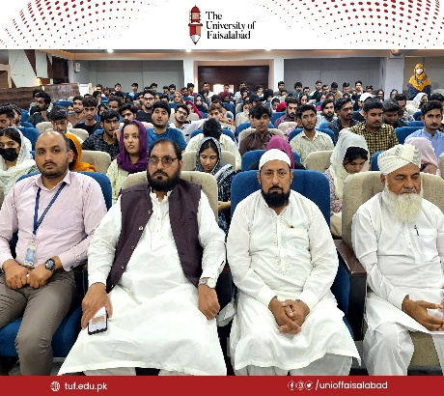
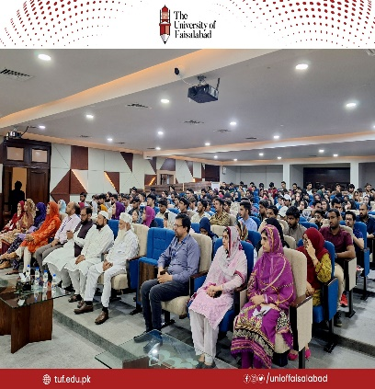 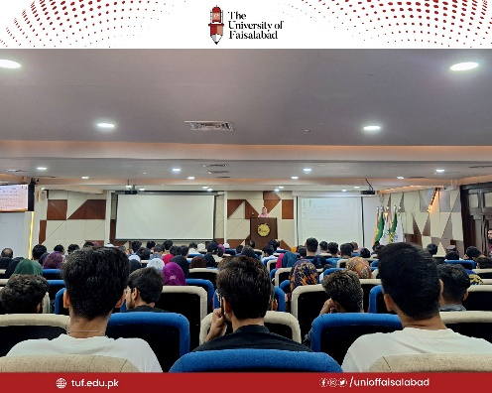 10-09-2024
A seminar on the jurisprudential services of Hazrat Imam Ja'far al-Sadiq was organized by the Department of Islamic Studies at Amin Campus. The event commenced with the recitation of the Holy Quran and a Naat. Dr. Matloob Ahmad provided an overview of Hazrat Imam Ja'far al-Sadiq's contributions in jurisprudence.
The guest speaker, Syed Muhammad Saeed ul Hassan Shah, delivered an in-depth discussion on the life and jurisprudential achievements of Hazrat Imam Ja'far al-Sadiq.Hazrat Imam Ja'far al-Sadiq was renowned for his vast knowledge, and even the Imams of that era sought his teachings. Imam Abu Hanifa, who received knowledge from Hazrat Imam Ja'far al-Sadiq, referred to him as "Imam-e-Azam." Additionally, Jabir Bin Hayyan, who is known as the father of chemistry, also benefited from Imam Ja'far al-Sadiq’s teachings.Faculty members from various departments and students from different disciplines showed great interest and listened attentively to the presentations
.

